Jefferson’s Foreign Affairs
Unfortunately, the peace that John Adams achieved with France did not last long. In 1803, France and Great Britain were again at war. As the conflict heated up, both nations began seizing American ships that were trading with their enemy. President Jefferson, complained bitterly that “England has become a den of pirates and France has become a den of thieves.” Still, like Washington and Adams before him, Jefferson tried to follow a policy of neutrality.
Impressment and Embargo: Remaining neutral when ships were being seized was hard enough. It became even harder when Great Britain began impressing American sailors—kidnapping them and forcing them to serve in the British navy.
American anger grew over impressment, with some even calling for war. Meanwhile, Jefferson tried desperately to convince both France and Great Britain to leave American ships alone. Unfortunately, all of his diplomatic efforts failed, and between 1803 and 1807, Great Britain seized at least a thousand American ships. That same year, France captured about half that many.
When diplomacy failed, Jefferson proposed an embargo— a complete halt in trade with other nations. Under the Embargo Act passed by Congress in 1807, no foreign ships could enter U.S. ports and no American ships could leave, except to trade at other U.S. ports. Jefferson hoped that stopping trade would prove so painful to France and Great Britain that they would agree to leave American ships alone.
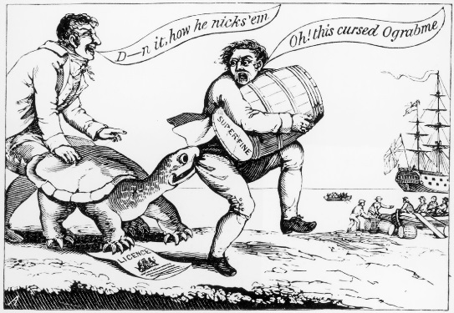
The embargo, however, hurt Americans more than anyone in Europe, and some 55,000 sailors lost their jobs. In New England, newspapers pointed out that embargo spelled backward reads “O grab me,” which made sense to all who were feeling its pinch.
Congress repealed the unpopular Embargo Act in 1809. American ships returned to the seas, and French and British warships continued to attack them.​
Piracy: American ships faced a different threat from the Barbary States of North Africa: piracy, or robbery at sea. For years, pirates from Morocco, Algiers, Tunis, and Tripoli had preyed on merchant ships entering the Mediterranean Sea, so that they could seize the ships and hold the crews for ransom.
Presidents Washington and Adams both paid tribute to Barbary State rulers in exchange for the safety of American ships. While Americans were shouting “millions for defense, but not one cent for tribute” during the XYZ Affair, the United States was quietly sending money to the Barbary States.

