Jefferson’s Domestic Affairs
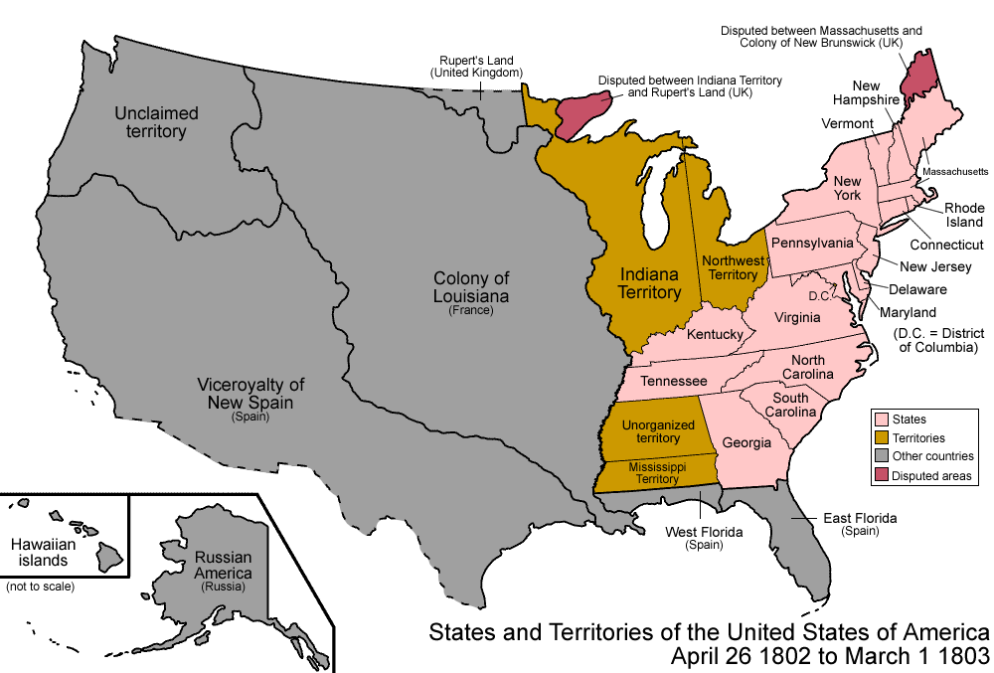
The Mississippi River: By 1801, President Jefferson had stepped into office, and there were over one million Americans living in the area between the Appalachian Mountains and the Mississippi River. Most of them were farming families, and the fact that this area was undeveloped (few roads, bridges, or tunnels) meant that they relied on the Mississippi River to ship their goods to consumers in different states and countries.
At the southern end of the Mississippi River was the French controlled city of New Orleans, which was extremely important to U.S. trade. Ships that traveled down the Mississippi River had to pass through the port of New Orleans to reach the Gulf of Mexico and onward to the Atlantic Ocean.
In 1803, this led President Jefferson to send advisors to see if they could buy the port city from the French.
The Deal of a Lifetime: Napoleon had been holding on to New Orleans and the Louisiana Territory with hopes of expanding the French empire, but war with Britain over in Europe, and a new slave revolt in French controlled Haiti forced Napoleon to reconsider his priorities. When Jefferson's advisors, Napoleon agreed to sell New Orleans, but only if the U.S. would purchase the entire Louisiana Territory too. The price tag for this huge piece of land: Just 15 million dollars.
Jefferson's advisers didn't have time to relay the offer back to the President and wait for a response, but they were not about to let this deal pass them up. Believing Jefferson would approve of it, they decided to make the deal. Of course President Jefferson did approve. In today's dollars, $15 million would be about $283 million. That may sound like a lot, but keep in mind that the U.S. currently spends nearly $4 trillion every year. It was an absolute bargain. For about 4 cents per acre, the U.S. doubled its territory, gained control of New Orleans, and no longer had the French in their backyard.
The Lewis and Clark Expedition: Even before the purchase was made, Jefferson was planning on sending out an expedition to explore the western territories, Like so many before, Jefferson was hoping this expedition would find the fabled Northwest Passage, but now the crew had an addition task: to explore the land Jefferson had just purchased. To lead this expedition, Jefferson chose his personal secretary Meriwether Lewis. As his co-captain, Lewis chose his friend William Clark.
For more than two years, the crew made its way to the Pacific Ocean and back, and while they never found the Northwest Passage, they collected all kinds of information on the new territory. They drew maps of the routes they took, journaled about their experiences in the wild, and took countless notes on the people, plants and animals the encountered. This information would pave the way for future explorers and settlers of the great American frontier.

